The Interreg VI-A Lithuania–Poland Cooperation Programme Project No. LTPL00388 “Networking towards Successful Resocialization of Convicts and Uniting Society for Common Trust” is being implemented.
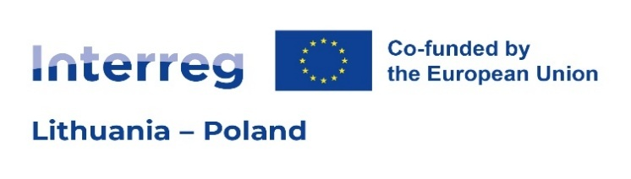
On 21 November 2025, the Lithuanian Prison Service and the Ministry of the Interior of the Republic of Lithuania signed a subsidy agreement for the project “Networking towards Successful Resocialisation of Convicts and Uniting Society for Common Trust” (No. LTPL00388).
The project seeks to strengthen the resocialization of convicted persons and parolees in the Lithuanian–Polish border region by enhancing interinstitutional cooperation, increasing community engagement, and fostering public trust. Particular emphasis is placed on reducing social stigma and expanding access to employment and social integration opportunities.
Key Activities
To achieve these objectives, the project is organized into two main work packages:
Work Package 1 – Strengthening the Networking and Cooperation Capacity of Local Actors Involved in Resocialization of Convicts
Within this work package, institutional capacities and inter-institutional cooperation are strengthened to ensure a more effective resocialization process. Joint workshops and training sessions for Lithuanian and Polish professionals are organized to establish a sustainable cooperation network and to enhance professional competencies for working with convicted persons and supporting their reintegration.
Main activities:
• Joint workshops and training sessions for Lithuanian and Polish professionals.
• Development of a research tool and conducting public attitude surveys on resocialization at the beginning and at the end of the project.
Work Package 2 – Promoting Communities’ Involvement to Foster Common Trust and Successful Resocialization of Convicts
This work package promotes public engagement and fosters positive community interaction with convicted persons.
Main activities:
• Joint initiatives for the renewal of public spaces (in Alytus, Pravieniškės, and the Kaunas district).
• Creative activities and street art projects within the Lithuanian and Polish correctional systems.
• Support group meetings for convicted persons and their families.
• International sports events — a volleyball tournament in Lithuania and a football tournament in the Polish border region — involving community members, convicted persons, and institutional staff.
Expected Outcomes:
Activity | Expected outcomes | Outcomes achieved
Participations in joint cross-border actions | 348 | -
Participation in workshops and training activities | 216 | -
Active participation of community members and convicted persons in joint initiatives | 132 | -
Cross-border partner organizations | 6 | -
Jointly organised cross-border public events | 2 | -

Partners and Budget
Project partners: the Lithuanian Prison Service, the Lithuanian Probation Service, the Regional Inspectorate of the Prison Service in Olsztyn.
Associated partners: the municipalities of Alytus City, Kaunas District, and Kaišiadorys District.
The total project budget amounts to €376,876.12, of which €301,500.89 is co-financed by the European Regional Development Fund (ERDF).
Partner | Country | Partner Budget, EUR | ERDF Share (80%), EUR | Partner Contribution (20%), EUR
Lithuanian Prison Service | LT | 179 460,00 | 143 568,00 | 35 892,00
Lithuanian Probation Service | LT | 83 521,12 | 66 816,89 | 16 704,23
Regional Prison Inspectorate in Olsztyn | PL | 113 895,00 | 91 116,00 | 22 779,00
The project will be implemented over a 24-month period, from 1 January 2026 to 31 December 2027.
Programme website: www.lietuva-polska.eu
_________________

